Year 4 Addition
Concept | Concrete | Pictorial | Abstract
Add up to two 4 digit numbers with no exchange. | 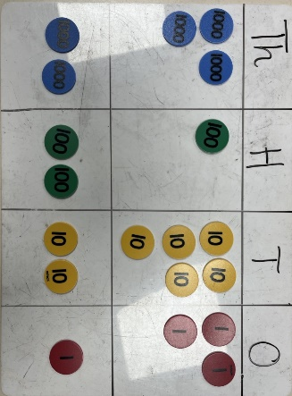 | 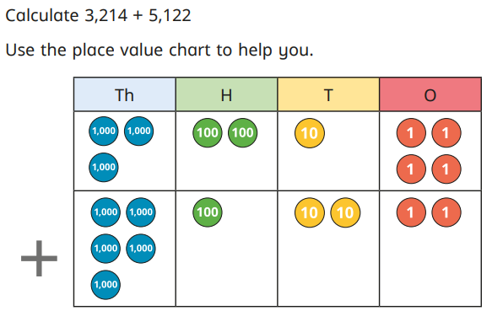 | 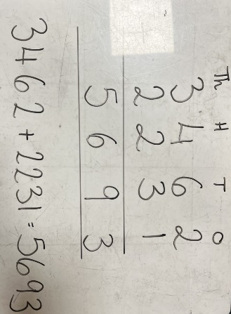
Add two 4 digit numbers- with exchanges. | 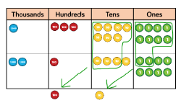 | 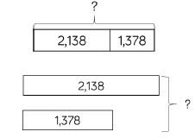 | 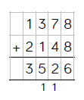
Year 4 Subtraction

Concept | Concrete | Pictorial | Abstract
Subtract two 4 digit numbers- no exchange | 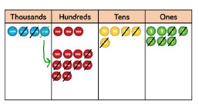 | 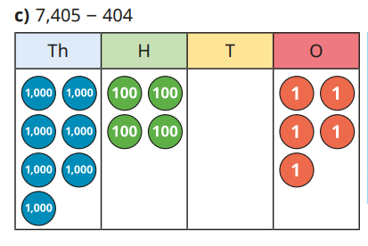 | 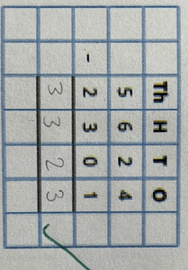
Subtract two 4 digit numbers- with exchanges | 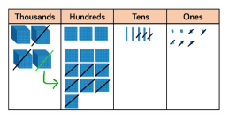 | 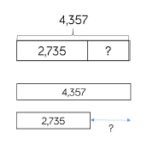 | 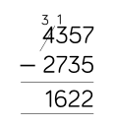
Year 4 Multiplication
Concept | Concrete | Pictorial | Abstract
Recall and apply multiplication and division facts for 6 times tables | 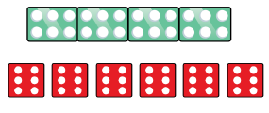 | 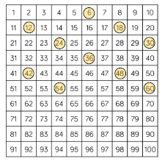 | 3 x 6 = 18  6 x 3 = 18  18 divided by 3 = 6  18 divided by 6 = 3
Recall and apply multiplication and division facts for 7 times tables | 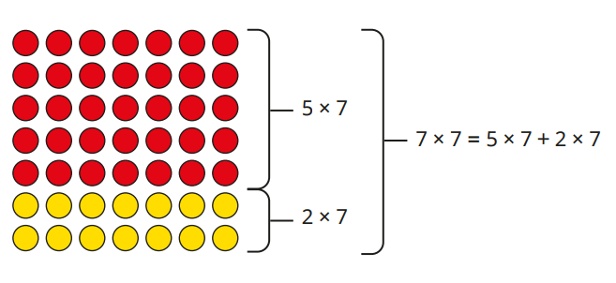 | 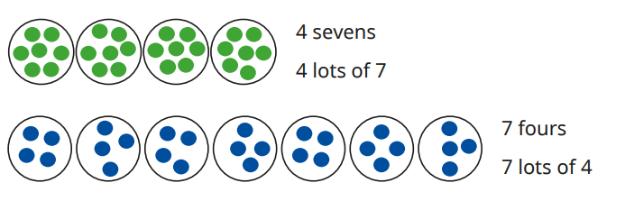 | 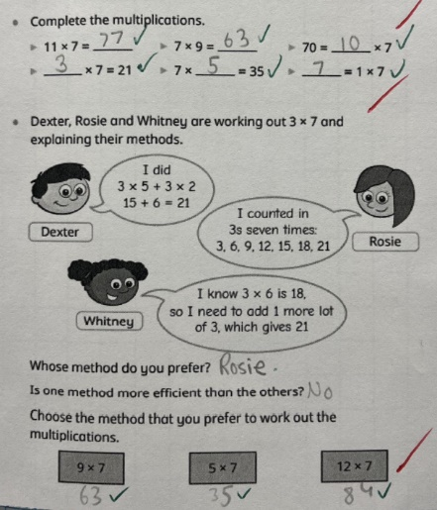
Recall and apply multiplication and division facts for 9 times tables | 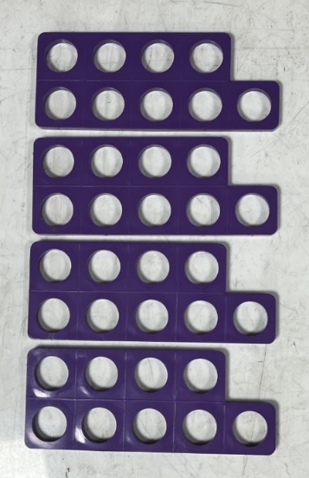 | 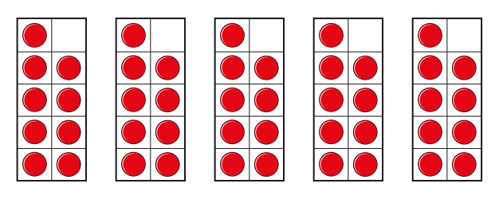 | 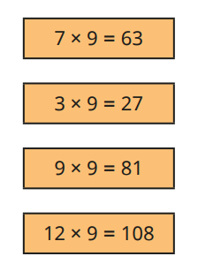
Recall and apply multiplication and division facts for 11 times tables | 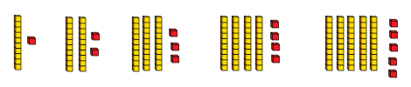  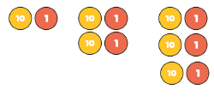 | 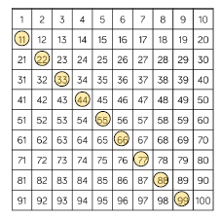  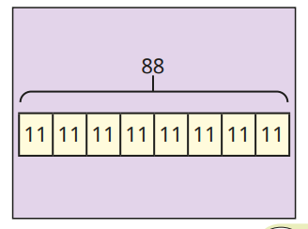 | 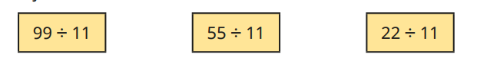
Recall and apply multiplication and division facts for 12 times tables | 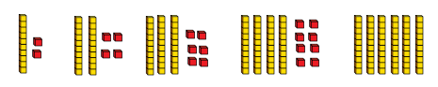 | 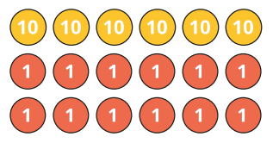 | 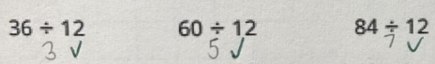  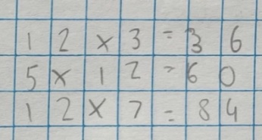
Use informal written methods for multiplication | 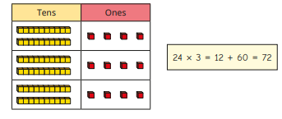 | 34 x 6 = 204  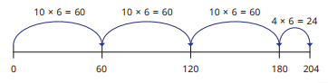 | 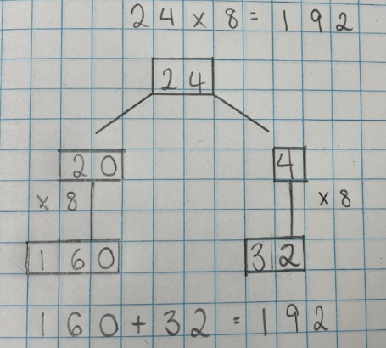
Multiply up to 3 digit number by a 1 digit number- no exchange | 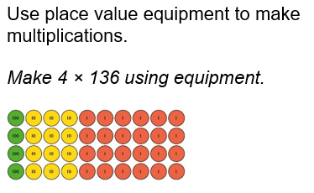 | 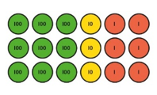 | 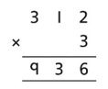
Multiply a 3 digit number by a 1 digit number with exchanges | 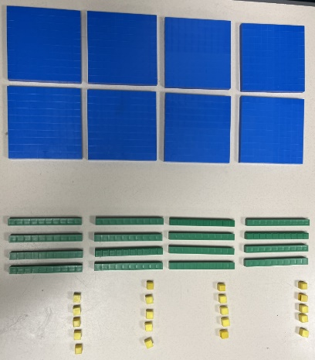  245 x 4 = | 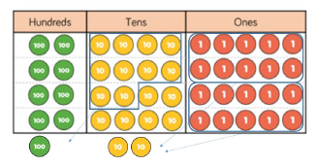 | 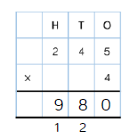
Year 4 Division
Concept | Concrete | Pictorial | Abstract
Divide 2 and 3 digit numbers using formal written method of short division | 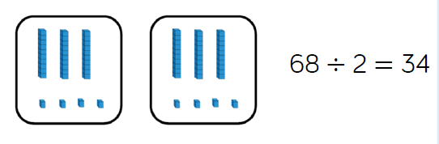 |  | 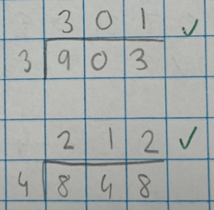  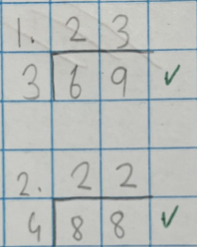
Divide 2 and 3 digit numbers using formal written method of short division- with remainders |  | 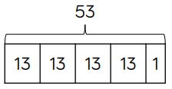 | 

